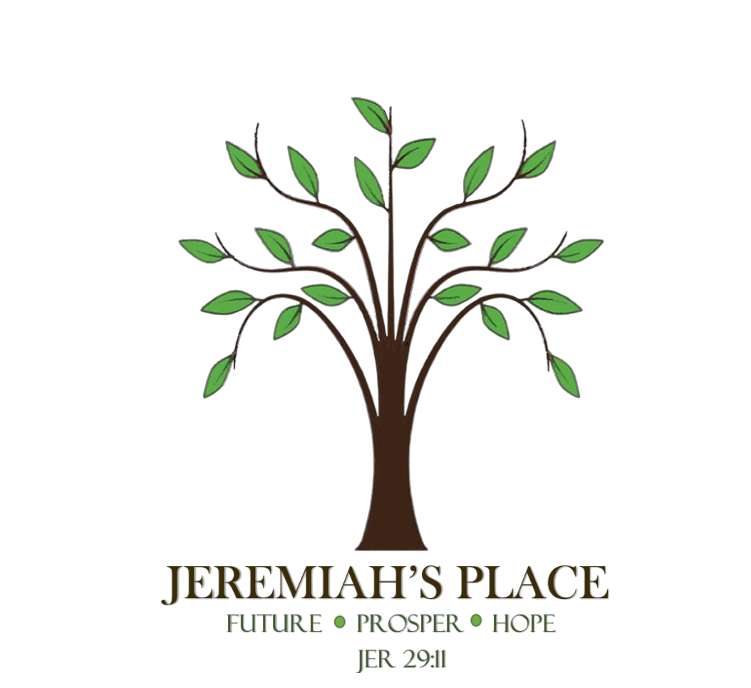

Jeremiah’s Place
North Georgia Interfaith Ministries Inc.
1445 Red Oak Flats Rd
Dahlonega, GA 30533
706-867-5404

ASSESSMENT PACKET

Please send completed form to intake4housing@gmail.com

Last Name ___________________ First Name ___________________ Middle Initial ________________
Age Age of Dependents
Any other names you have used? _________________________________________________________
Last permanent address _________________________________________________________________
How long since you lived at this address ____________________________________________________
Photo ID? No Yes Expiration Date ___________ ID # ______________________ State _____________
SS# ________________ Date of birth _____________________
Family Type (Check one) :
Single Female _____ Single Female w/child(ren) ______ Couple ______ Couple w/child(ren) ________
Are you seeking transitional housing with Jeremiah’s Place? Yes ____ No ____ How many people are you seeking housing for ______ Adults ______ Children ______
Do you have reliable transportation? Yes ____ No ____
Email Address ________________________________ Cell Phone # ______________________________
Emergency Contact Person ___________________________________ Phone # ____________________
Race (Check All) : American Indian ___ Asian ___ Black/African American ___ White ___ Other ________
Ethnicity : Hispanic/Latino ____ Not Hispanic/Latino ____
Gender : Female ____ Male ____ Other ____
Veteran : Yes ____ No ____ When Served _________________________ Discharged ________________
Marital Status : Single ____ Divorced ____ Widowed ____ Married ____ Separated ____
Highest Level Of Education : Some High School ____ Diploma ____ GED ____ College ____
Are you able to read and write in English? Yes ____ No ____
How long have you been in Lumpkin County? ________________________________________________
Where were you living before coming to Lumpkin County? How long? _____________________________________________________________________________________
Where is your nearest family? ____________________________________________________________
Do you have any family or friends close by you can stay with? ___________________________________
Who in your family are you closest to? ________________________________ Relationship __________
Do you have a support system? Yes ___ No ___
How would you describe your relationship with your family? Good ____ Fair ____ Poor ____
Do you have an open case with DFCS? ______ Case Manager Name ______________________________
Case Manager Phone # _______________________ What County _______________________________
What other Service Providers, Churches, or Agencies have you received assistance from? _________________________________________________________________________________________________________________________________________________________________________________________________________________________________________________________________________________________________________________________________________________
Where did you sleep last night?
__ Emergency shelter, __ Hotel paid for by shelter, Church or agency __ Transitional or permanent housing for __ Foster care or foster care group home
homeless persons __ Psychiatric hospital or other facility
__ Substance abuse treatment center/detox center __ Hospital (non-psychiatric)
__ Jail, prison or juvenile detention facility __ Staying or living with a family member
__ Home owned by you/Rented by you __ Place not meant for habitation (car, tent etc.)
__ Staying or living with a friend __ Hotel or motel paid for by you

Residence Contact Name : ________________________________ Phone # ________________________

How long have you been sleeping at last night’s residence? (Check one)
__ 1 week or less __ 1 week to 1 month __ 1 to 3 months __ 3 months to 1 year __ 1 year or longer

How many times in the last 3 years have you been homeless? _____ times How long this time? _______

Housing Status: ___ Literally homeless ___ Unstable housing/at risk of losing housing ___ Stable housing

Housing:

Rental History
Have you ever had a lease in your name? ____Yes ____No
Have you ever had utilities in your name? ____Yes ____No Last deposit amount $________
Have you ever been evicted from housing? ____Yes ____No How many times? ______
What was the reason for eviction? ________________________________________________________
Would a prior landlord give you a good reference? ____Yes ____No

Where have you lived and with whom for the past 5-8 years?

City/Town State With Whom How Long Landlord Name and phone#

_____________________________________________________________________________________
City/Town State With Whom How Long Landlord Name and phone#

City/Town State With Whom How Long Landlord Name and phone#

City/Town State With Whom How Long Landlord Name and phone#

City/Town State With Whom How Long Landlord Name and phone#

Credit History
Do you have unpaid rent and/or utility bills in your name? ____ Yes ____ No
Do you have a credit history (loan, financing, utilities, rent-to-own) ____ Yes ____ No
Do you think you have poor credit? ____ Yes ____ No

Criminal History
Have you EVER been convicted of a misdemeanor? ____ Yes ____ No
Have you EVER been convicted of a felony? ____ Yes ____ No
If yes, what? ___________________________________ When? ________________________________
Are you currently on probation? ____ Yes ____ No Parole? ____ Yes ____ No
Name of probation/parole officer ______________________ Location ___________________________

Indicate ANY and ALL misdemeanors and/or felonies you have been ARRESTED for, in the past 10 years :
Charge Date of Arrest Conviction
1
2
3
4
5
6
Medical:
How would you rate your general health right now? __Excellent __Good __ Fair __ Poor
Are you currently taking any medications? Yes ___ No ___ What? _______________________________
Are you supposed to take any medications but do not? Yes ___ No ___ What? _____________________

Reason for not taking these medications? ___________________________________________________
__________________________________________________________________________________________________________________________________________________________________________

What health conditions if any do you have?__________________________________________________ ____________________________________________________________________________________________________________________________________________________________________________________________________________________________________________________________________________________________________________________________________________________

Do you have a regular doctor? Yes ___ No ___ Who _____________________ Where _______________
Do you have any know allergies? Yes __ No __ What? _________________________________________
Do you currently use alcohol? Yes ___ No ___ Frequency ______________________________________
Do you currently use drugs? Yes ___ No __ Frequency ________________________________________
Do you have a history of alcohol or drug abuse? Yes ___ No ___
Have you ever received treatment for a mental health issue? Yes ___ No __
If yes – explain ________________________________________________________________________
_________________________________________________________________________________________________________________________________________________________________________________________________________________________________________________________________________________________________________________________________________________________________________________________________________________________________________
Are you pregnant? Yes __ No __ HIV Status? Neg __ Pos __ Don’t know ___
Have you applied for disability? Yes ___ No ___
Is there any other information that would be important to know about your health? ________________
____________________________________________________________________________________________________________________________________________________________________________________________________________________________________________________________________________________________________________________________________________________

Health Barriers:
Physical Health
Has your physical disability impacted your homeless situation? Yes ___ No ___ How? _______________
_______________________________________________________________________________________________________________________________________________________________________________________________________________________________________________________________
Does your physical health affect your ability to get housing, or limit your housing options? Yes __ No __
How? ________________________________________________________________________________
_____________________________________________________________________________________
Do you have any special needs that would qualify you for an “ADA” compliant unit? Yes ___ No____ Explain _______________________________________________________________________________
__________________________________________________________________________________________________________________________________________________________________________
Mental Health
Have you EVER lost your housing because of your mental health? (being hospitalized, having neighbors complain about your behavior because of symptoms that stopped you from taking care of yourself, your home etc.). Yes ___ No ___ Explain ________________________________________________________
__________________________________________________________________________________________________________________________________________________________________________
Do you have a mental health issue that currently affects your ability to get housing? Yes __ No __

Substance Abuse
Has substance use (drugs or alcohol) EVER caused you to lose your housing? Yes ___ No ___
Do you think current substance use could affect your ability to get housing? Yes ___ No ___

Domestic Violence/Abuse
Are you currently fleeing abuse? Yes ___ No ___
Has domestic violence or abuse EVER caused you to lose your housing? Yes ___ No ___
Have you EVER been the victim of domestic violence or abuse? Yes ___ No ___ When __________
Type : Physical ___ Emotional ___ Verbal ___ Financial ___ Spiritual ___ Other ________

Income Information:

Have you received ANY income from ANY source in the past 30 days? Yes ___ No ___

Income Sources and Amount Yes No Amount Date Started
Employment
Unemployment
SSI
SSDI
Veteran Disability Payment
Veteran Pension
Retirement Income
Pension from former job
Child Support
Alimony
Other sources

Non-cash Benefits Received Yes No Amount Date Started
Food Stamps/SNAP
TANF
Medicaid Health Insurance Program
Medicare Health Insurance
VA Medical Services
Section 8, Public Housing, Rental Assistance
Other

Monthly Expenses Amount
Landlord
Power Company
Water Department
Gas Company
Phone Company (Home Phone/Cable/Internet)
Child Care
Child Support
Alimony
Justice System (Probation, Fines, Fees etc.)
Medical
Car Loan
Car Insurance
Credit Card debt
Personal Loan
Cell Phone
Gas (Car)
Title loan/Pawn
Back child support
Past Medical Bill
Past Utility Bill
Other

Is there any other information you would like to share about your financial situation? _______________
_______________________________________________________________________________________________________________________________________________________________________________________________________________________________________________________________

Income Barriers

Are you employed? Yes ___ No ___ Where _____________________________ How Long __________
Part Time ____Full Time ____ Seasonal ____ How Many Hours ______ Pay $_____ per hr./week/month

Is your spouse employed? Yes ___ No ___ Where _______________________ How Long ___________
Part Time ___ Full Time ___ Seasonal ___ How Many Hours _____ Pay $ _____ per hr./week/month

How much can you afford to spend on housing each month right now?

$300-$500 ___ $501-$600 __ $601-$700 __ $701-$800 __ More than $801 __

Previous Work History

Employer: _________________________ Location: _________________ Dates: ____________
Employer: _________________________ Location: _________________ Dates: ____________
Employer: _________________________ Location: _________________ Dates: ____________
Employer: _________________________ Location: _________________ Dates: ____________
Employer: _________________________ Location: _________________ Dates: ____________

Do you have the following (originals, not photocopies) for all family members? Please check each that apply:

Birth Certificate ___ State Issued ID ___ Driver’s License ___ Social Security Card ___

Names of all DOB M/F Relationship Any Special Needs Who has
Family Members Primary Custody
1
2
3
4
5
6
7

Who referred you to Jeremiah’s Place? ________________________________________________

Have you ever participated in the program at Jeremiah’s Place or lived at Jeremiah’s Place before?
Yes ___ No ___

If yes, when? ______________________________________________________________________

Reason for leaving? _________________________________________________________________

Signature: ________________________________ Date: ______________

THE FUTURE

By this time next year I see myself living ____________________________________________________
______________________________________________________________________________________________________________________________________________________________________________________________________________________________________________________________________________________________________________________________________________________________________________________________________________________________________________________________________________________________________________________________

Identify 3 goals you hope to accomplish in the next couple of months ____________________________
______________________________________________________________________________________________________________________________________________________________________________________________________________________________________________________________________________________________________________________________________________________________________________________________________________________________________________________________________________________________________________________________

How do you expect to accomplish them? ___________________________________________________
______________________________________________________________________________________________________________________________________________________________________________________________________________________________________________________________________________________________________________________________________________________________________________________________________________________________________________________________________________________________________________________________

How will living in Transitional Housing at Jeremiah’s Place help you to accomplish these goals and how? ___________________________________________________________________________________________________________________________________________________________________________________________________________________________________________________________________________________________________________________________________________________________________________________________________________________________________________________________________________________________________________________________________________________________________________________________________________________

Is there any other information you would like us to consider? ___________________________________
_______________________________________________________________________________________________________________________________________________________________________________________________________________________________________________________________

Jeremiah’s Place
North Georgia Interfaith Ministries Inc.
1445 Red Oak Flats Rd
Dahlonega, GA 30533
706-867-5404

Family Consent Form

And, in granting this Consent, I acknowledge that:

I am signing this form freely and have not been forced or coerced to do so. This consent form has been read by me or to me, and I have received a copy of this form. I have been given the opportunity to discuss the content of this form and the consent being granted under it, and I understand that by signing this form I am giving Jeremiah’s Place (North Georgia Interfaith Ministries Inc) permission to verify ALL information given by me and also authorize Jeremiah’s Place (North Georgia Interfaith Ministries Inc) to contact any persons named within. I have been given the opportunity to ask any questions regarding such consent and content. Any such questions have been answered to my full satisfaction, and I understand the consent I am granting by signing below.

_________________________________ ____________________________________ ______________
Signature Print Name Date

_________________________________ ____________________________________ ______________
Staff Signature Staff Print Name Date

To ensure there is no fraudulent use of this consent form, a head of household must be specified, and the names and dates of birth for any and all minor children for whom I am legally responsible must be listed below.

Head of Household (please print):

___________________________ ___________________
Name DOB

Minors’ Names and dates of Birth (please print):

_______________________________ ________________
_______________________________ ________________
______________________________ ________________
_______________________________ ________________
_______________________________ ________________

Jeremiah’s Place
North Georgia Interfaith Ministries Inc.
1445 Red Oak Flats Rd
Dahlonega, GA 30533
706-867-5404

RELEASE OF INFORMATION FORM

Before you decide whether or not to allow Jeremiah’s Place to share any of your information with another agency or person, the Program Director will discuss with you all alternatives and any potential risks and benefits that could result from sharing your information. Communication between Jeremiah’s Place and the agency/person named below may occur in a variety of ways (in person, phone conversation, text, email, fax, instant message etc.) and may include information contained in your assessment. You have the right to choose what is shared, how it is shared, to whom and for how long.

AGENCY NAME ______________________________________________________
CONTACT PERSON ___________________________________________________
PHONE NUMBER ____________________________________________________
SPECIFIC INFORMATION TO RELEASE ______ OR OBTAIN _______
______________________________________________________________________________________________________________________________________________________________________________________________________________________________________________________________________________________________________________________________________________________________________________________________________________________________________________________________________________________________________________________________

Release Date _______________ Expiration Date __________________________

_________________________ ______________________ _____________
Signature Print Name Date

_________________________ __________________ __________
Staff Signature Staff Print Name Date

